DevOps Periodic Table : The Ultimate Cheat Sheet
DevOps is quite a popular term in today’s market. Almost all enterprises use this methodology on a daily basis for a successful and beneficial software development lifecycle. But, as we all know, DevOps needs various kinds of tools to implement its complete lifecycle. In this article on DevOps Periodic table, I will discuss the top tools you can use, and also segregate them into various sections.
For your better understanding, I have divided the periodic table into the following categories:

  - Source Code Management
  - Database Automation
  - Continuous Integration
  - Testing
  - Configuration Management
  - Deployment
  - Containers
  - Release Orchestration
  - Cloud
  - Artificial Intelligence Operations
  - Analytics
  - Monitoring
  - Security
  - Collaboration

DevOps Periodic Table
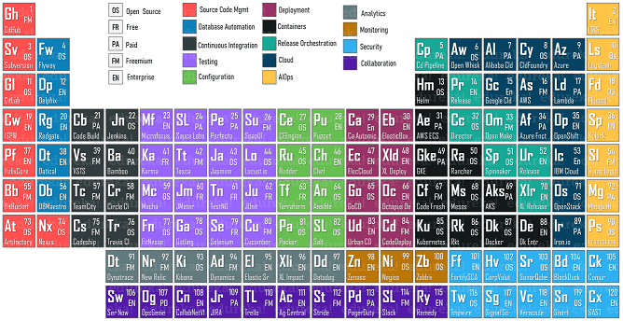
As you can see from the above DevOps periodic table, we have 14 categories in which I have divided a few of the most popular tools used in today’s market. In this article, let us discuss each of these categories one by one.

DevOps Periodic Table: Source Code Management
While we start developing an application using the DevOps methodology, one of the initial steps is to build code. Since every application has a code running at its background which needs to be updated based on a requirement, it is very important to manage the source code. The source code management tools provide versions to indicate which user has made the changes at what time. The most popular tools in this section are as follows:

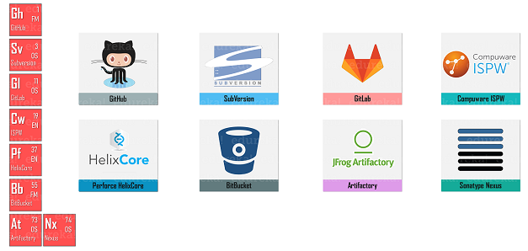

DevOps Periodic Table: Database Automation
Databases play an integral role in any kind of application. But, it is almost next to impossible for the developers to perform administrative tasks in databases very frequently. So, database automation is the usage of self-updating and unattended processes for various administrative tasks in the database. With this kind of automation, you can reduce errors in deployments, improve the speed, and increase reliability. Few of the popular tools used for this purpose are as follows:

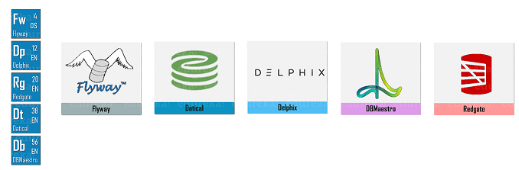

Continuous Integration
Continuous Integration is the heart of the DevOps Lifecycle, as all the members of a team integrate their work quite frequently. Each and every integration is verified by an automated build to detect the integration that occurs as soon as possible. Here, you just have to keep in mind that you have to choose a reliable method integrating to ensure that errors are found much sooner in the CI/CD pipeline. Few of the popular continuous integration servers are as follows:

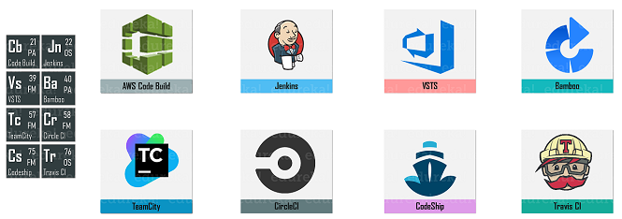

DevOps Periodic Table: Testing
Once your application is built, the next step is to check whether it is working fine or not. Well, this is where software testing plays an important role. Through this stage, you can check your application/ software for bugs and resolve the same. If there are any bugs found, then the software undergoes the software development lifecycle. Software testing can be either manual or automated, and also has many levels like unit testing, integration testing, system testing, and acceptance testing. Refer below for few of the most used tools:

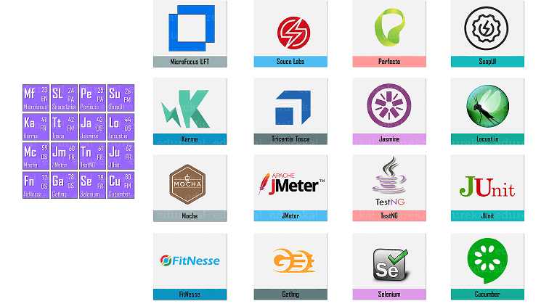

DevOps Periodic Table: Configuration Management
Configuration Management is a process through which you can handle the changes in a systematic manner. This process ensures that the integrity is maintained overall time, and the present state of the system is in a known and a good state. The top tools used in configuration management are as follows:

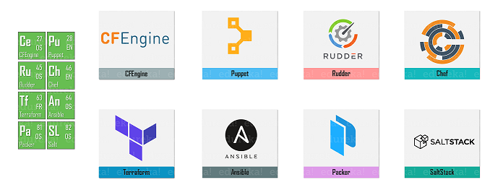
DevOps Periodic Table: Deployment
After your application has been tested and is ready to be rolled into the production, deployment is the next stage that comes into the picture. Here, the application is deployed into the production environment using various tools based on the enterprise or the application structure. The top tools used for the deployment stage are as follows:

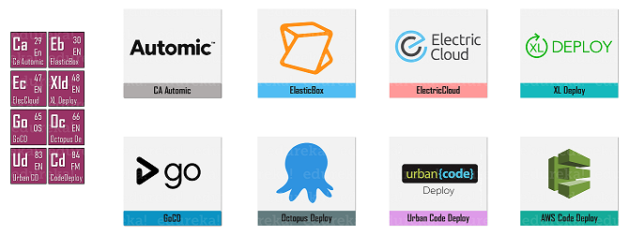
DevOps Periodic Table: Containers
Containers are a new concept that has emerged in today’s market to build applications. Containerization has enabled the users to build the application with the help of microservices, wherein all the required packages and libraries for service are packaged into a single container. Few of the most popular containers present in today’s market are as follows:

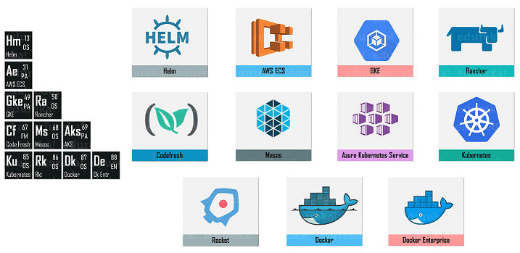
DevOps Periodic Table: Release Orchestration
As the name suggests, release orchestration is a way to automate, orchestrate and manage the end-to-end software release pipelines. These tools help you automate your CI/CD pipeline and also let you take the complete advantage of tools and practices, which you might have used while developing your

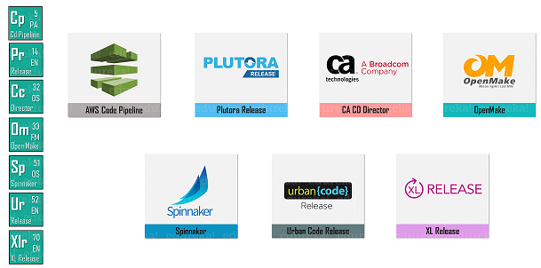

DevOps Periodic Table: Cloud
Cloud is the means of storing or accessing your data over the internet rather than your own hard drive. Everything nowadays is moved to the cloud, running on the cloud, accessed from the cloud or may be stored on the cloud. The application or the software that you build can be deployed on the cloud. There are many cloud providers in today’s market, but below are a few popular cloud providers that you can consider to use.

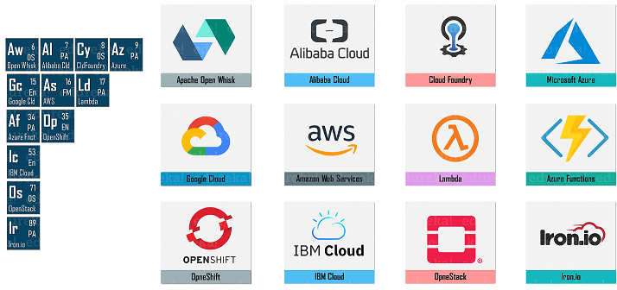

DevOps Periodic Table: Artificial Intelligence Operations
Artificial intelligence Operations or AIOps is a broad term for big data analytics, machine learning, and other AI technologies or frameworks. This is used to analyze the data of an application by using the various concepts such as Big Data and Machine Learning. Few of the most popular tools used in today’s market for AIOps are as follows:

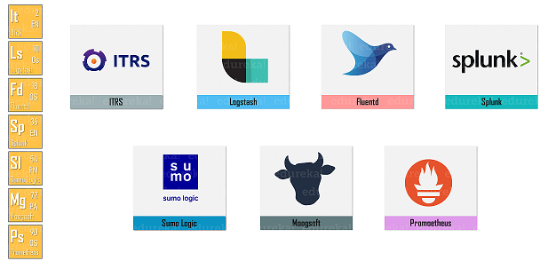

DevOps Periodic Table: Analytics
Analytics is used to analyze the data captured by an application. This set of tools are mainly used to analyze and generate insightful reports. There are many tools used to analyze the data, but few tools are very popular in the DevOps industry. They are:

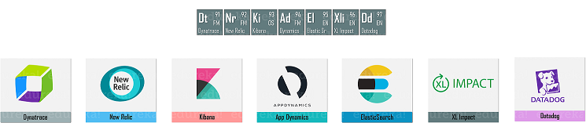

DevOps Periodic Table: Monitoring
Once the application is rolled out into the production, it is very important to monitor the application make sure its performance is good, it is taking less time to load, all the features and functionalities of the application are working properly, and other such factors. So, to continuously monitor the applications you can use the tools as below:

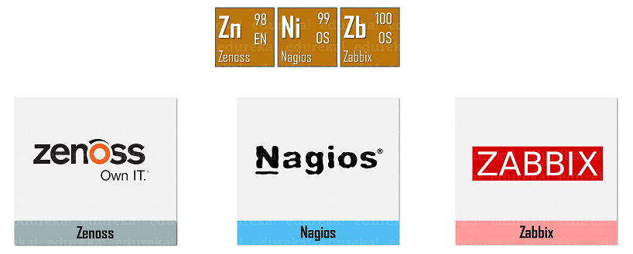

DevOps Periodic Table: Security
With the increasing number of threats or vulnerabilities, securing the application is one of the most important factors. There are various methods and technologies using which you can secure your application from different kinds of attacks. But, the top tools you can use to secure your application are as follows:

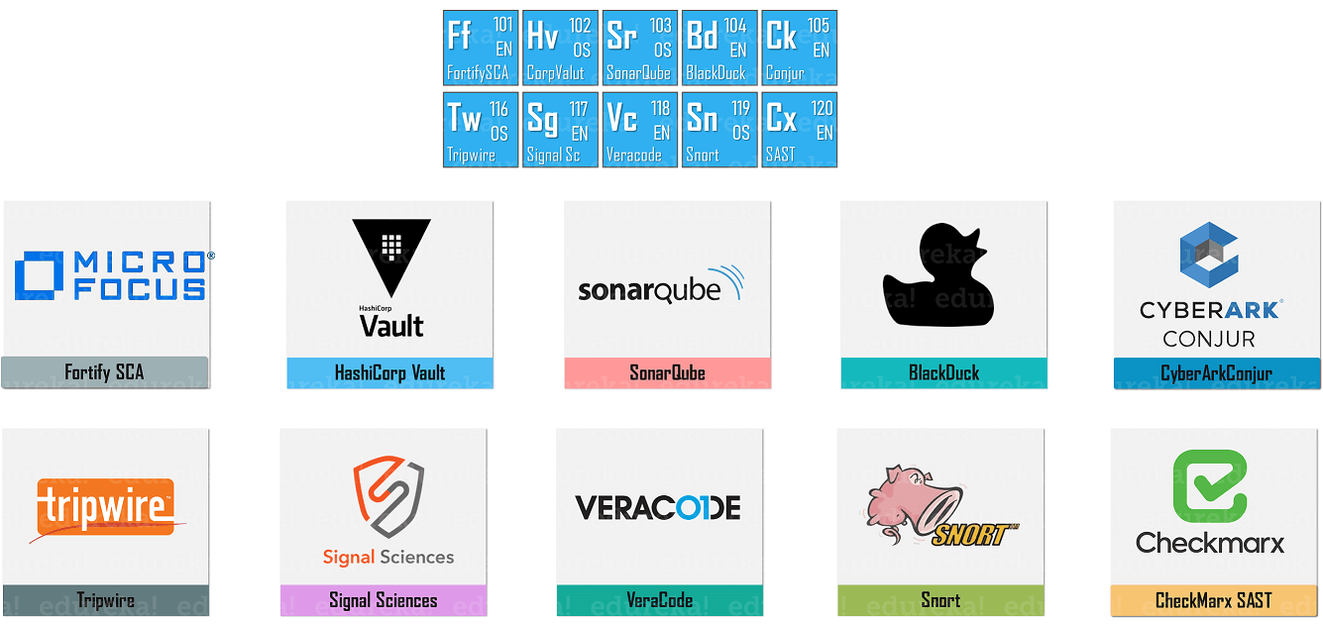

DevOps Periodic Table: Collaboration
Collaboration is something that is very important for each and every application in today’s market. An application or software is not of much use if it is used just for one purpose. Instead, if your software collaborated with the other software present in the market, then it proves to be beneficial to both of them. So, the top tools through which you can collaborate your software is as follows:
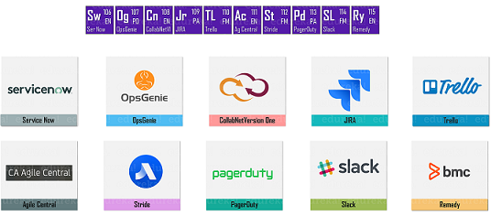
With that, we come to an end to DevOps periodic table. These were a few tools that I thought were important for the complete life cycle of DevOps. You can choose any tool that you wish to based on your requirements. A word of caution, for each and every stage, choose the tool, which will blend with the other tools easily and will benefit you the maximum for a successful software development life cycle.
If you found this article on “DevOps Periodic Table” relevant, check out the DevOps training by Edureka, a trusted online learning company with a network of more than 450,000 satisfied learners spread across the globe. The Edureka DevOps Certification Training course helps learners gain expertise in various DevOps processes and tools such as Puppet, Jenkins, Docker, Nagios, Ansible, and GIT for automating multiple steps in SDLC.

